Module 3 Assignment #1 – Survey Design
Things to Help You Succeed on This Assignment
- Read
  - Ch. 6 in Morling text or Ch. 32 “Observational Research,” Ch. 34 “Overview of Survey Research,” and Ch. 35 “Constructing Surveys” in open-access text
  - “America’s Complex Relationship with Guns” from the Pew Research Center (you only need to read the first page that the site lands on)
- Watch
  - Construct Validity of Surveys and Polls
  - Construct Validity of Behavioral Observations
- Practice
  - Quizzes
    - Review Quiz: Chapter 6
    - Case Studies: Surveys and Behavioral Observations
  - Assignments
    - Module 3 Practice Assignment #1
Client: Mx. Praxideke Meng, Zoning Board Chair
Request: Mx. Meng wants a recommendation from RM Consulting about whether they should approve a zoning permit for a new hunting and gun store based on people’s attitudes toward gun ownership.

Mx. Meng is the chair of the Zoning Board in their city and is dealing with a complicated question of whether to approve or disapprove an application for a store permit for a new hunting and gun shop. The rest of the board is evenly divided into approve and disapprove groups, so Mx. Meng is the tie-breaker. While they have their own opinions, Mx. Meng would like to rely on some research on people’s attitudes about guns and gun ownership to make their decision.
They found a report from the Pew Research Center about Americans’ attitudes around gun ownership and would like some help understanding it. Below is an excerpt from the beginning of the report (but make sure to check out the link, too):
“Whether for hunting, sport shooting or personal protection, most gun owners count the right to bear arms as central to their freedom. At the same time, the results of gun-related violence have shaken the nation, and debates over gun policy remain sharply polarized.
“A new Pew Research Center survey attempts to better understand the complex relationship Americans have with guns and how that relationship intersects with their policy views.

“The survey finds that Americans have broad exposure to guns, whether they personally own one or not. At least two-thirds have lived in a household with a gun at some point in their lives. And roughly seven-in-ten—including 55% of those who have never personally owned a gun—say they have fired a gun at some point. Today, three-in-ten U.S. adults say they own a gun, and an additional 36% say that while they don’t own one now, they might be open to owning a gun in the future.
“A third of adults say they don’t currently own a gun and can’t see themselves ever doing so.”
Step 1: Refer to the pie chart at the top of the report for the following questions.
1) The claim above the pie chart says that “about four in ten U.S. adults say they live in a gun-owning household.” What kind of claim is this?
2) Which of the four validities is going to be most important with this type of claim?
3) Take a look at the questions they asked for the data in the pie chart. In the table below are issues that people who write polling questions have to consider. For each issue in the list, analyze whether the Pew gun questions (in the pie chart) seem susceptible to this issue or not (and why or why not).
Acquiescence bias
Double-barreled questions
Negative wording
Fence-sitting
Faking good

Step 2: In the methodology section, the researchers provide this information about the sample and margin of error:
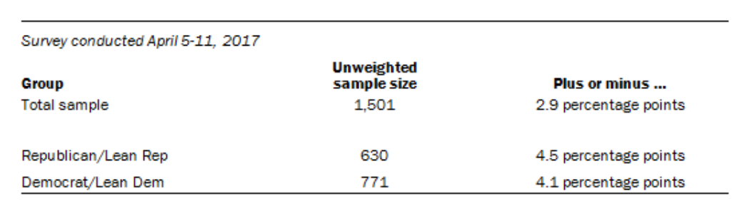
1) Why is the margin of error smaller for the total sample than it is for the sample of Republican/Lean Rep subsample or the Democrat/Lean Dem subsample?
2) There are about 4,000 people in the total sample for this poll. Is that enough to generalize to all Americans? Why or why not?
3) Why do you think the researchers at Pew did this: “Respondents in the landline sample were selected by randomly asking for youngest adult male or female who is now at home?” (Think about the implications of who is most likely to both own a landline and answer it.)
Step 3: Review the information you learned about attitudes of gun ownership in this report. (You can just scan the tables and charts to get a good idea of the results.)
1) Based on these data, would you advise Mx. Meng to approve or not approve the zoning permit? Things to keep in mind for this decision include: what the data results are, which questions/data are applicable to the recommendation, and whether the results could be generalized to Mx. Meng’s city.

